**7. Test Case ID: TC004**  
**Description:** Testing the website on different browsers (Cross-browser testing).

**Steps:**  
Open the website on different browsers, like Yahoo, to test it.

**Expected Result:**  
The website should work properly on all browsers.

**Actual Result:**  
The website worked properly on all browsers.

**Severity Level:** Low

**Assigned To:** No one.

**Remarks:** Test passed successfully.

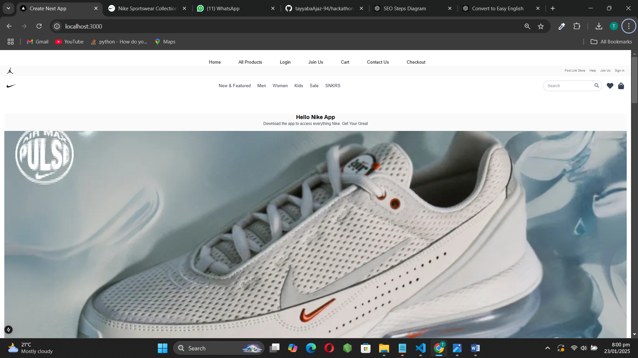

**Test Case ID:** TC003  
**Description:** Check if the cart works properly.  
**Steps:**

1. Add an item to the cart.
2. Go to the cart.

**Expected Result:** Items should show up in the cart.  
**Actual Result:** Items are showing up in the cart.

**Severity Level:** Medium  
**Assigned To:** (Not assigned yet)  
**Remarks:** Successful

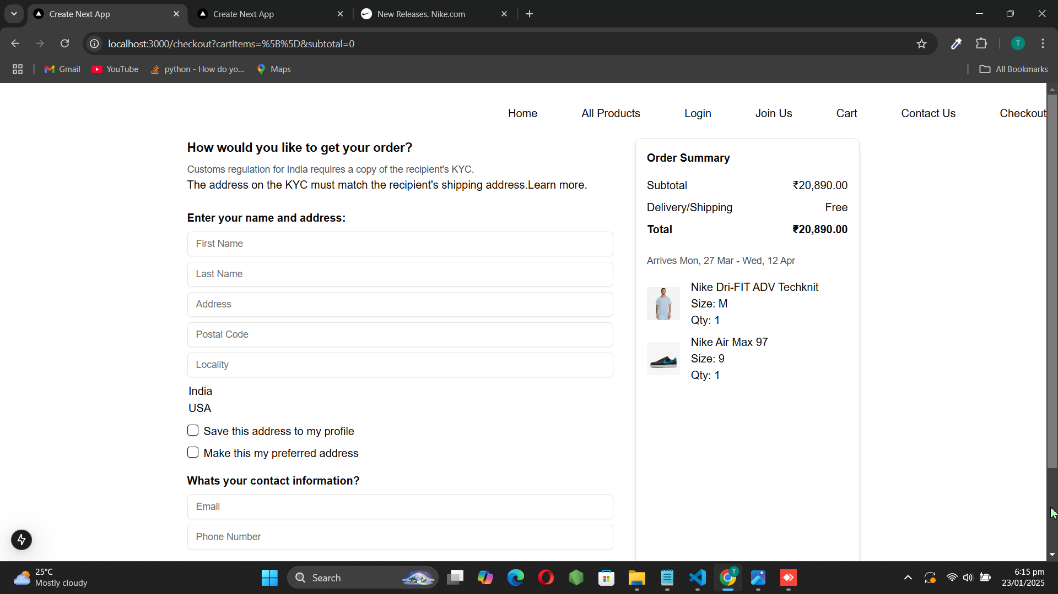

**Test Case ID:** TC002  
**Description:** Test API error handling.  
**Steps:**

1. Disconnect the Gorq Query.
2. Refresh the page.

**Expected Result:** The screen should show an error message.  
**Actual Result:** The screen shows the error message.

**Severity Level:** Low  
**Assigned To:** (Not assigned yet)  
**Remarks:** Handles errors gracefully.

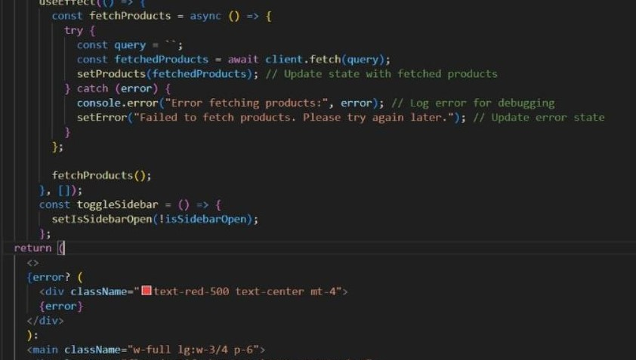

**Test Case ID: TC001**  
**Description:** Check if the product listing page works properly.

**Steps:**

1. Open the products page.
2. Check if the products are shown correctly.

**Expected Result:** Products should display properly.  
**Actual Result:** Products displayed properly.

**Severity Level:** Low  
**Assigned To:** No one.

**Remarks:** No issues found.

